

Internet of things PROJECTS/INTERNSHIP

# College Name

* ****SRM Institute of Science and Technology.****

# Company Name

* ****Vyorius.****

# Domain

* ****Internet of things.****

### Project topics

### IoT based on smart Agriculture System.

### World map covid-19 dashboard.

### Obstacle Avoidance Robot using Ultrasonic Sensor.

### RGB Pattern.

### 2.World map covid-19 dashboard

**Software's In detail**



The purpose of Grafana dashboards is **to bring data together in a way that is both efficient and organized**. It allows users to better understand the metrics of their data through queries, informative visualizations and alerts.



The Worldmap Panel is a tile map of the world that can be overlaid with circles representing data points from a query. It can be used with time series metrics, with geohash data from Elasticsearch or data in the Table format. The Worldmap panel needs two sources of data:

* a location (latitude and longitude)
* data that has a link to a location

The data comes from a database query: Prometheus, InfluxDB, Graphite, Elasticsearch, MySQL etc. It can be in the Time Series format or in the Table format.



InfluxDB provides **facilitates storage, monitoring, visualization, collecting data & providing alerts in time series data** which signifies its importance.



PyCharm is a dedicated Python Integrated Development Environment (IDE) providing a wide range of essential tools for Python developers, tightly integrated to create a convenient environment for **productive Python, web, and data science development**.

**Steps to follow**

**1-**Downlaod grafana

2-Dwonloadd influxDB

3- We are going to get the open-source version InfluxDB v1.8.6 , choose the platform. And copy the link just like it is shown, and paste in anew tab and then install it.

After that we have to extract and copy the file to program files to create a data base in our system

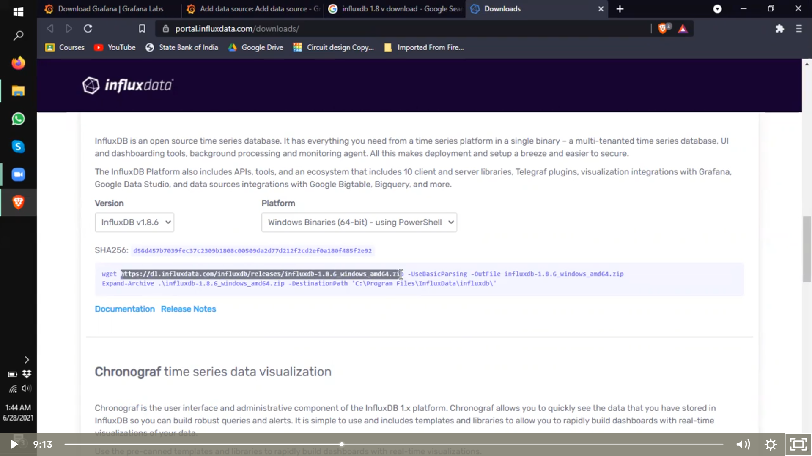

There is an already internal database created and what we are doing we are using influxDB to run through a medium and that medium is our laptop/pc.

After that we have to open two extracted file that has been copied and pasted.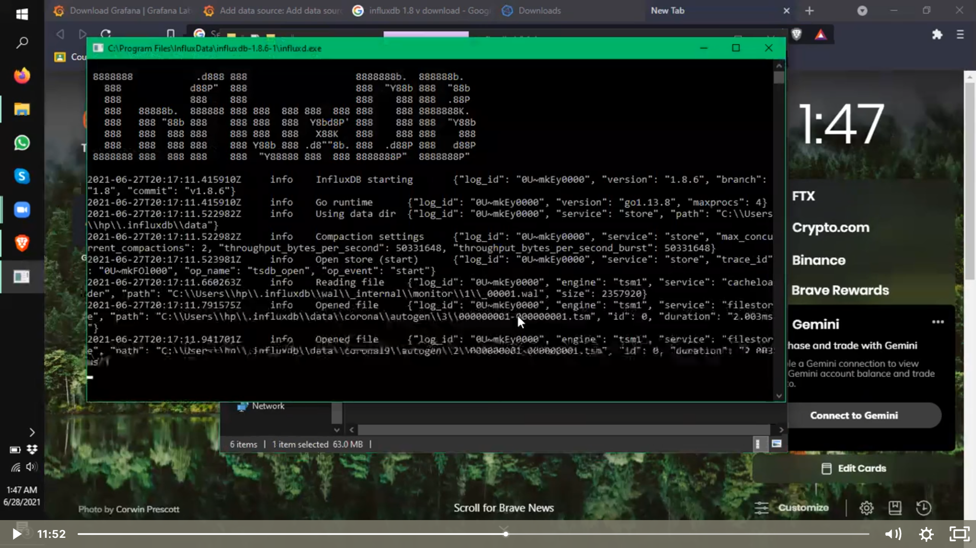

After filling necessary requirements as we can see we have created our data base.

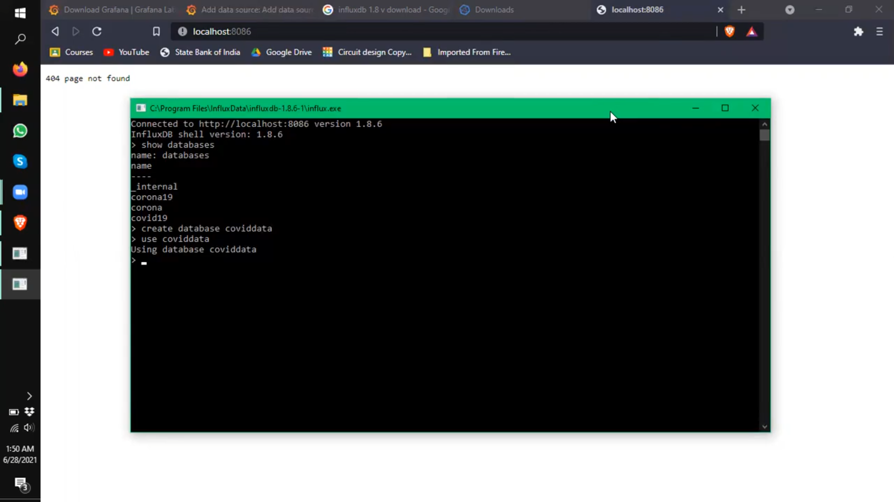

4-After that we have to go to grafana and select influx DB where we will get an option to upload the host URL, we got by creating a data base “http://localhost:8086/” and we have to name our data base as “covid data” after that we can save and test, we will see our data base is working properly.

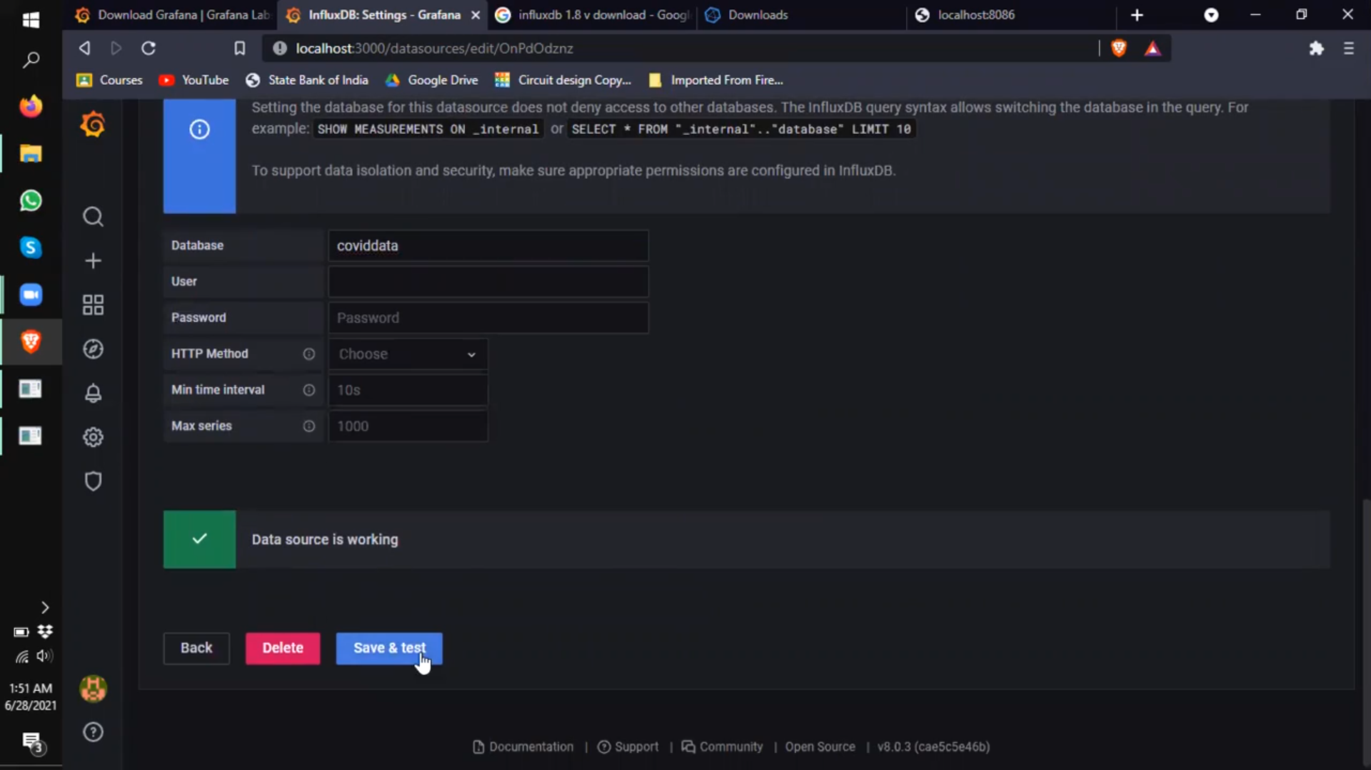Under data sources as we can see data base is installed or interfaced with grafana or our system.

6-We now have to create a dashboard, select on empty panel, and there we can see an option to insert the world map panel into it.

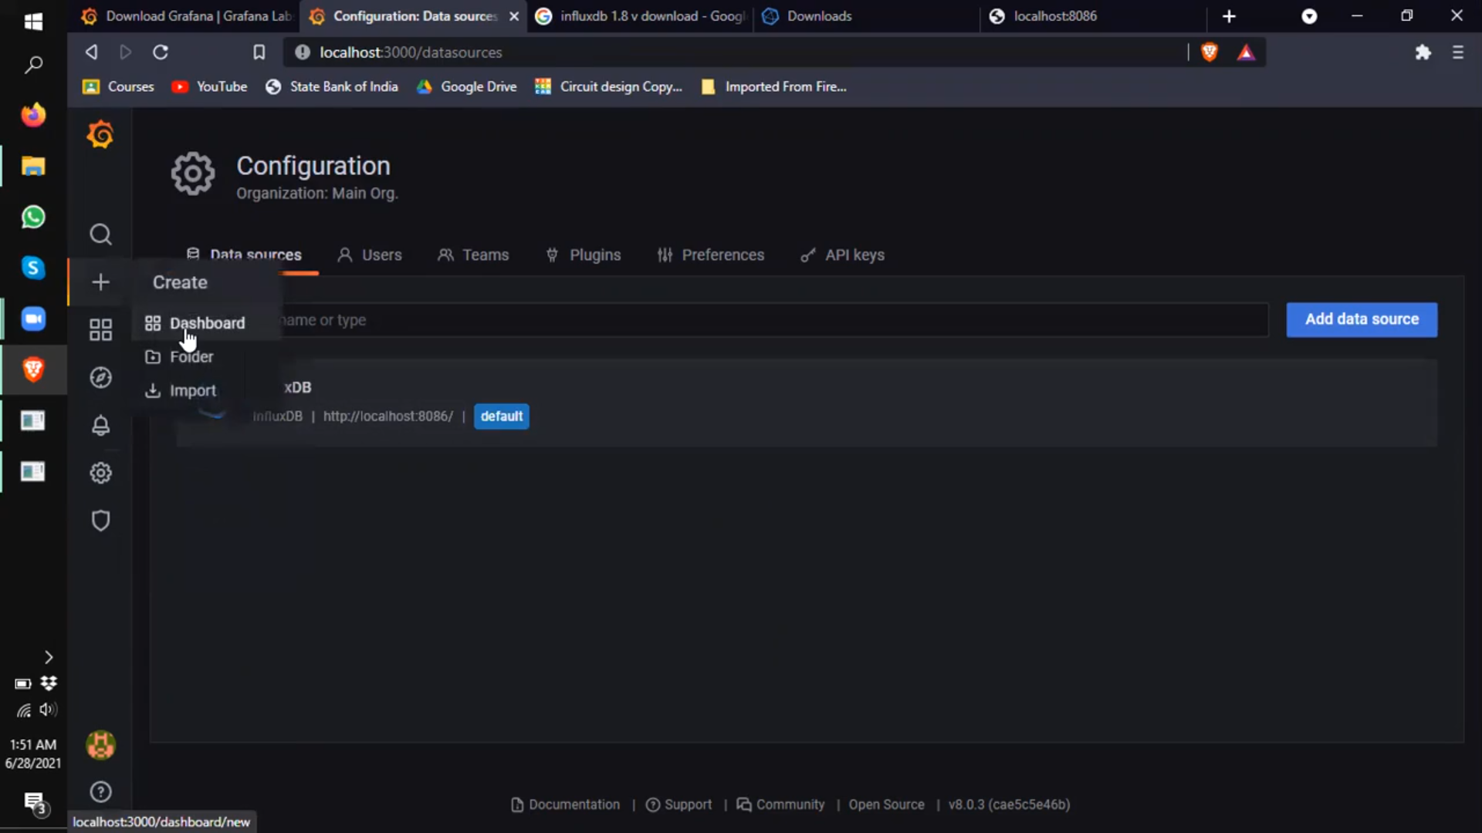

7-We have to download the world map panel plugin and interface with it in grafana, how we can do that?

Go to grafana file location

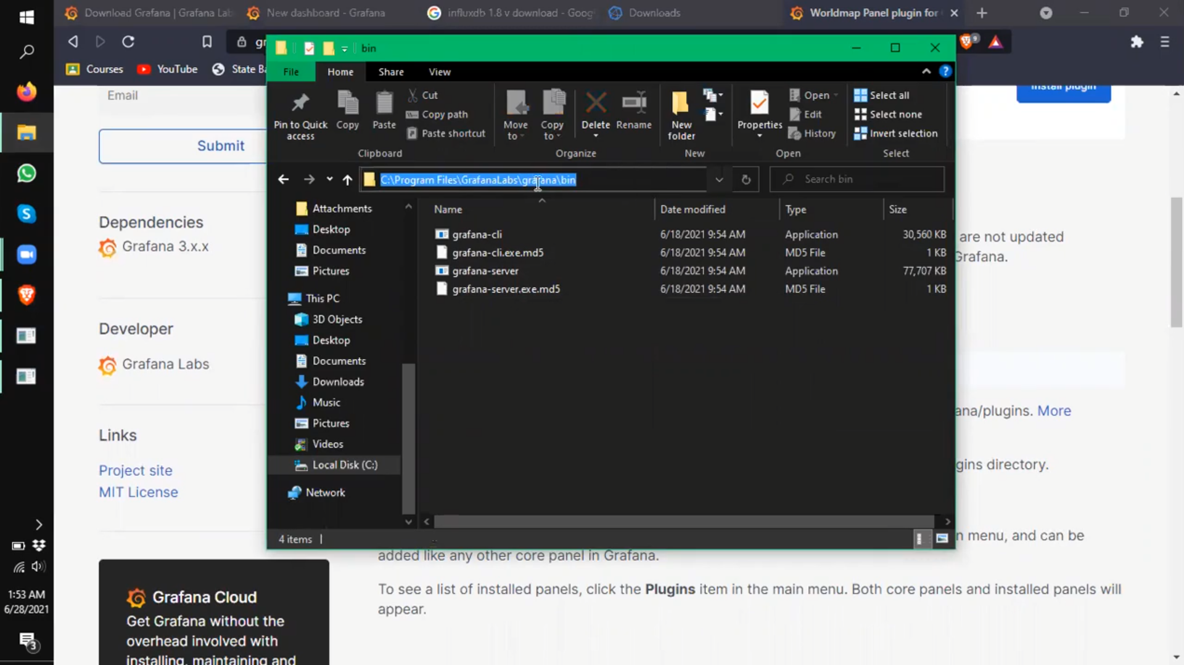

Copy the location and open command prompt as an administrator, and again copy the world map panel from the webpage

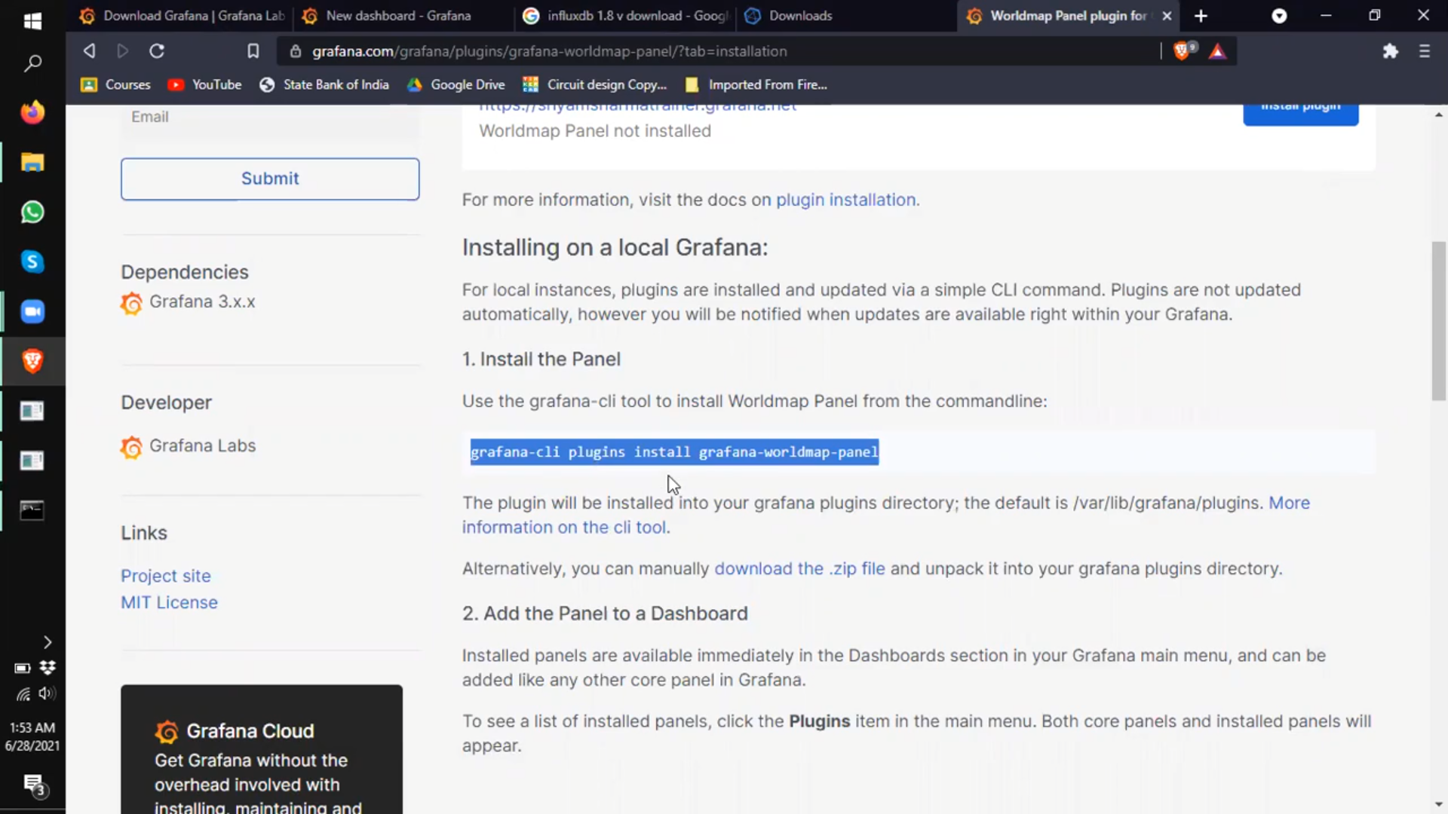

And paste it here

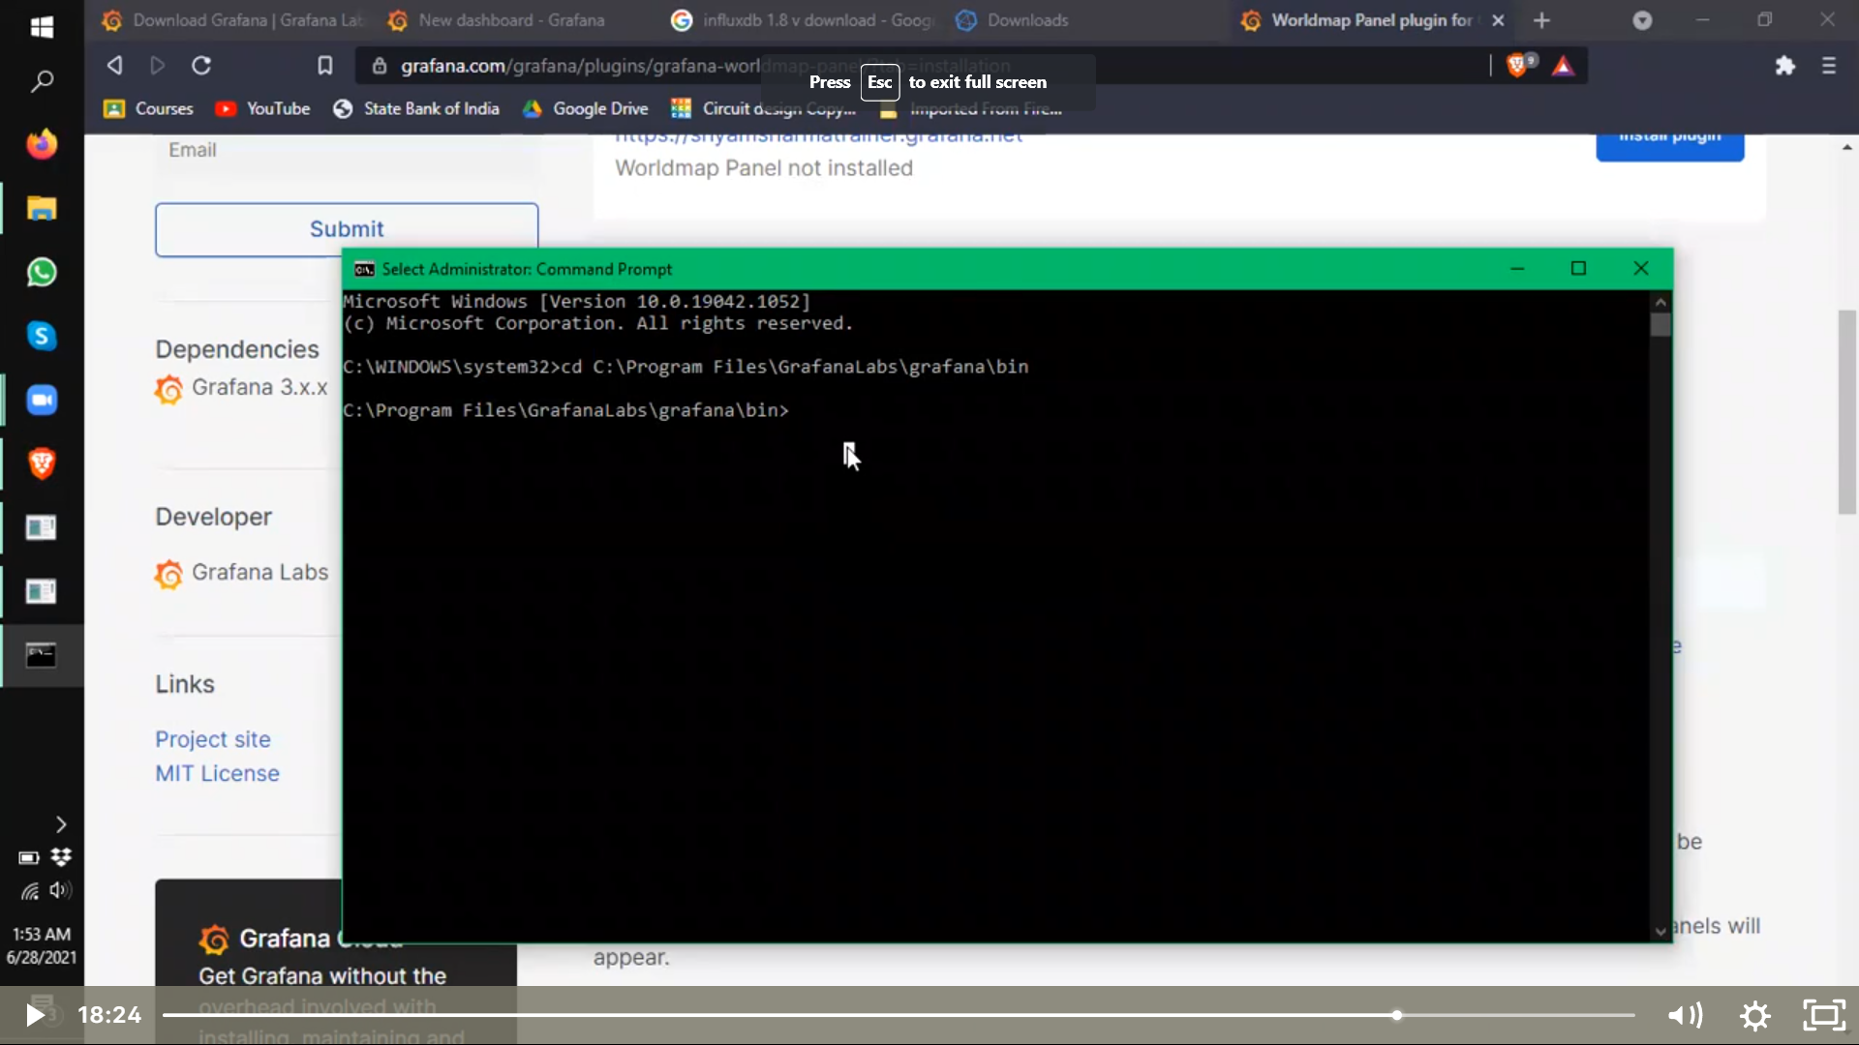

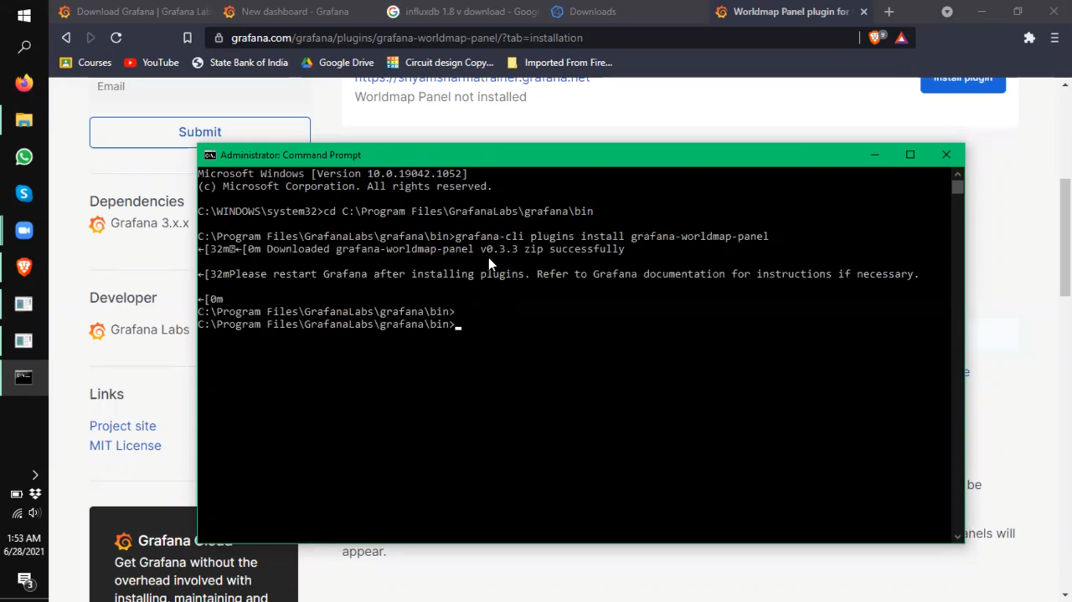

After that we can see that it is successfully installed in grafana still for betterment it is advisable to go to task manager go to services, find where grafana is and restart it.

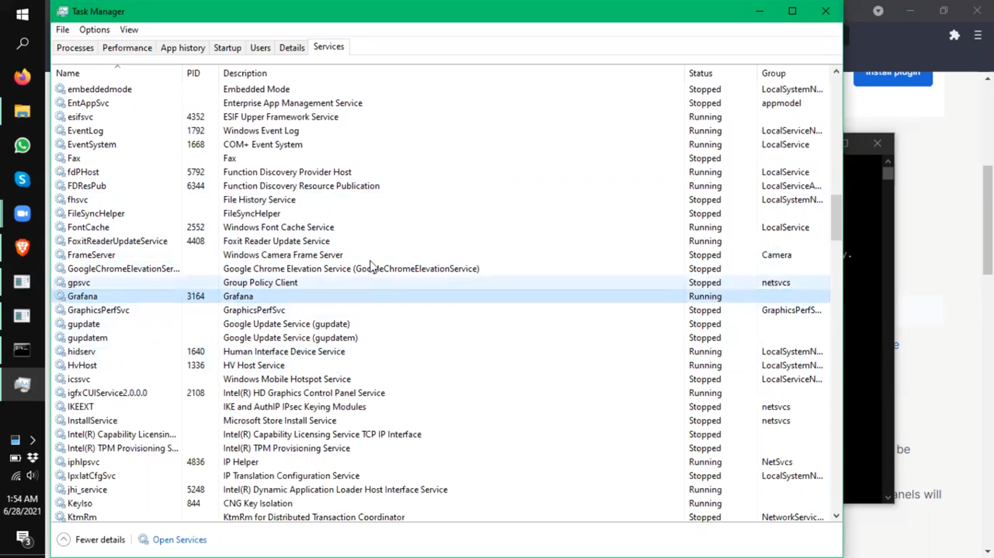

7- Go to the dashboard if it doesn’t appear create a new one and access the world map panel in it

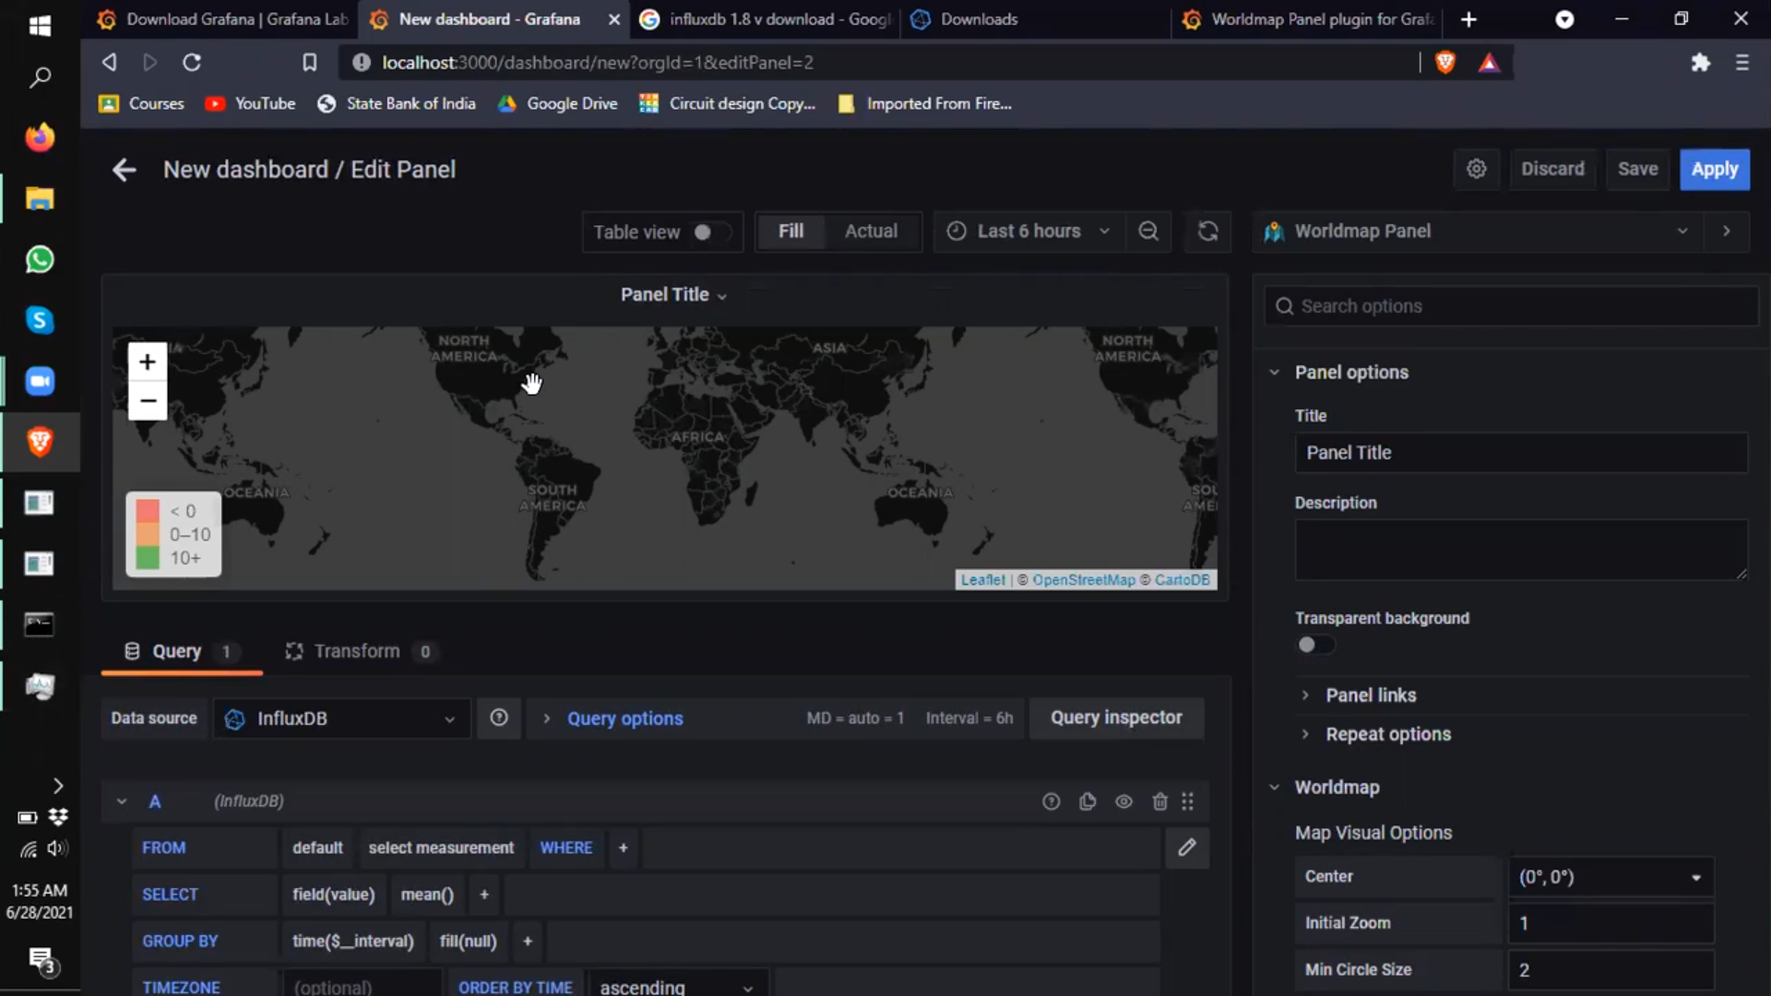8-Now we need data for the live active cases of corona virus in the world, so what we are doing we are going to a new tab search, track corona lives, go the website, under that you will find an option of API, then click on to get the data and download it as CSV as shown.

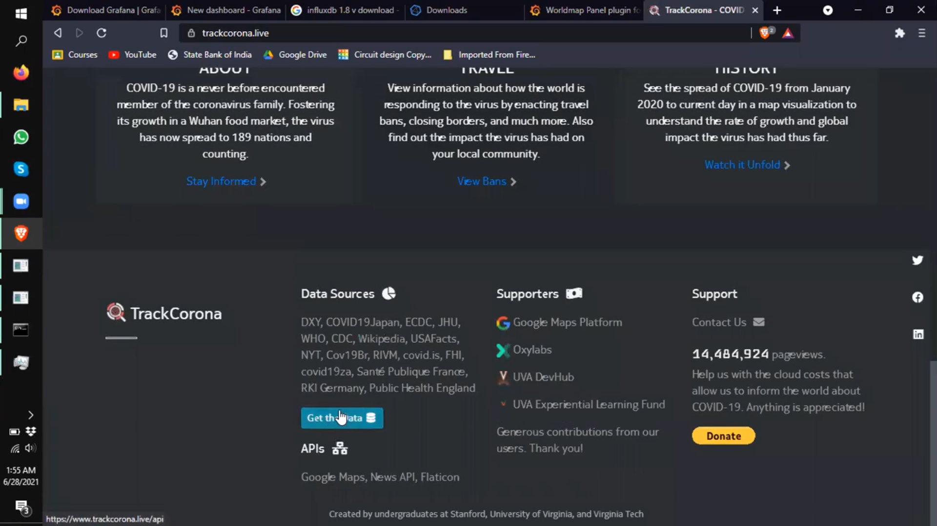

After downloading it can be seen that there are many excel file is installed if we open one, we can see there are data as location, country, latitude. Longitudes, confirmed cases, dead recovered dated.

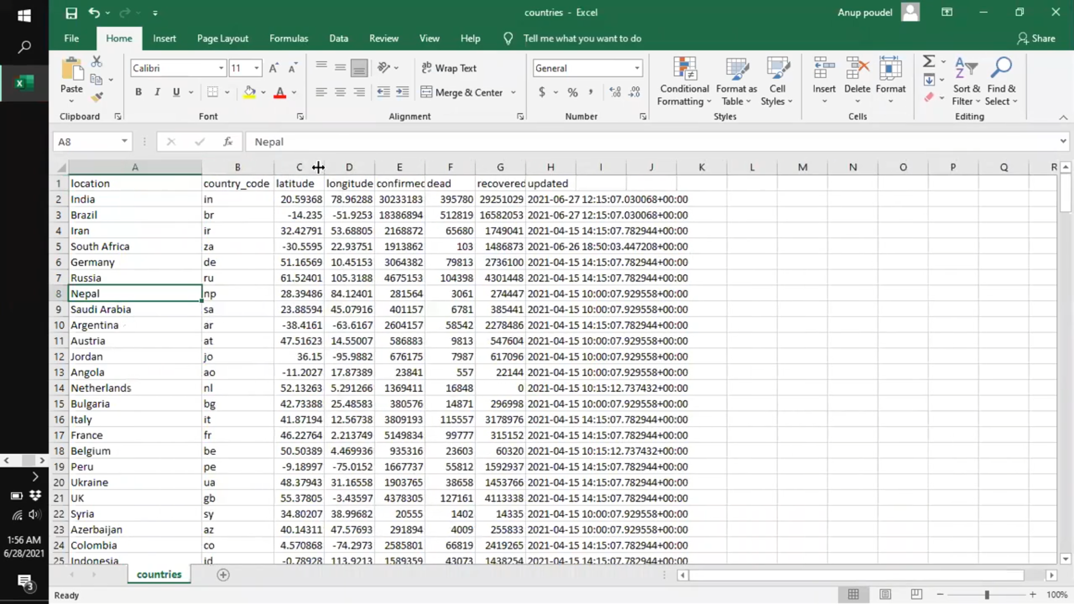9-Now to synch the data to our dashboard we are going to take help of python programming and run PyCharm. Now all we have to do in PyCharm we have to add two libraries, one is pandas and another one is influxdb , for that

Got to file -settings – project training- Python interpreter – click on the plus sign -

Then search the library we want in our case it is pandas, then select and install its package.

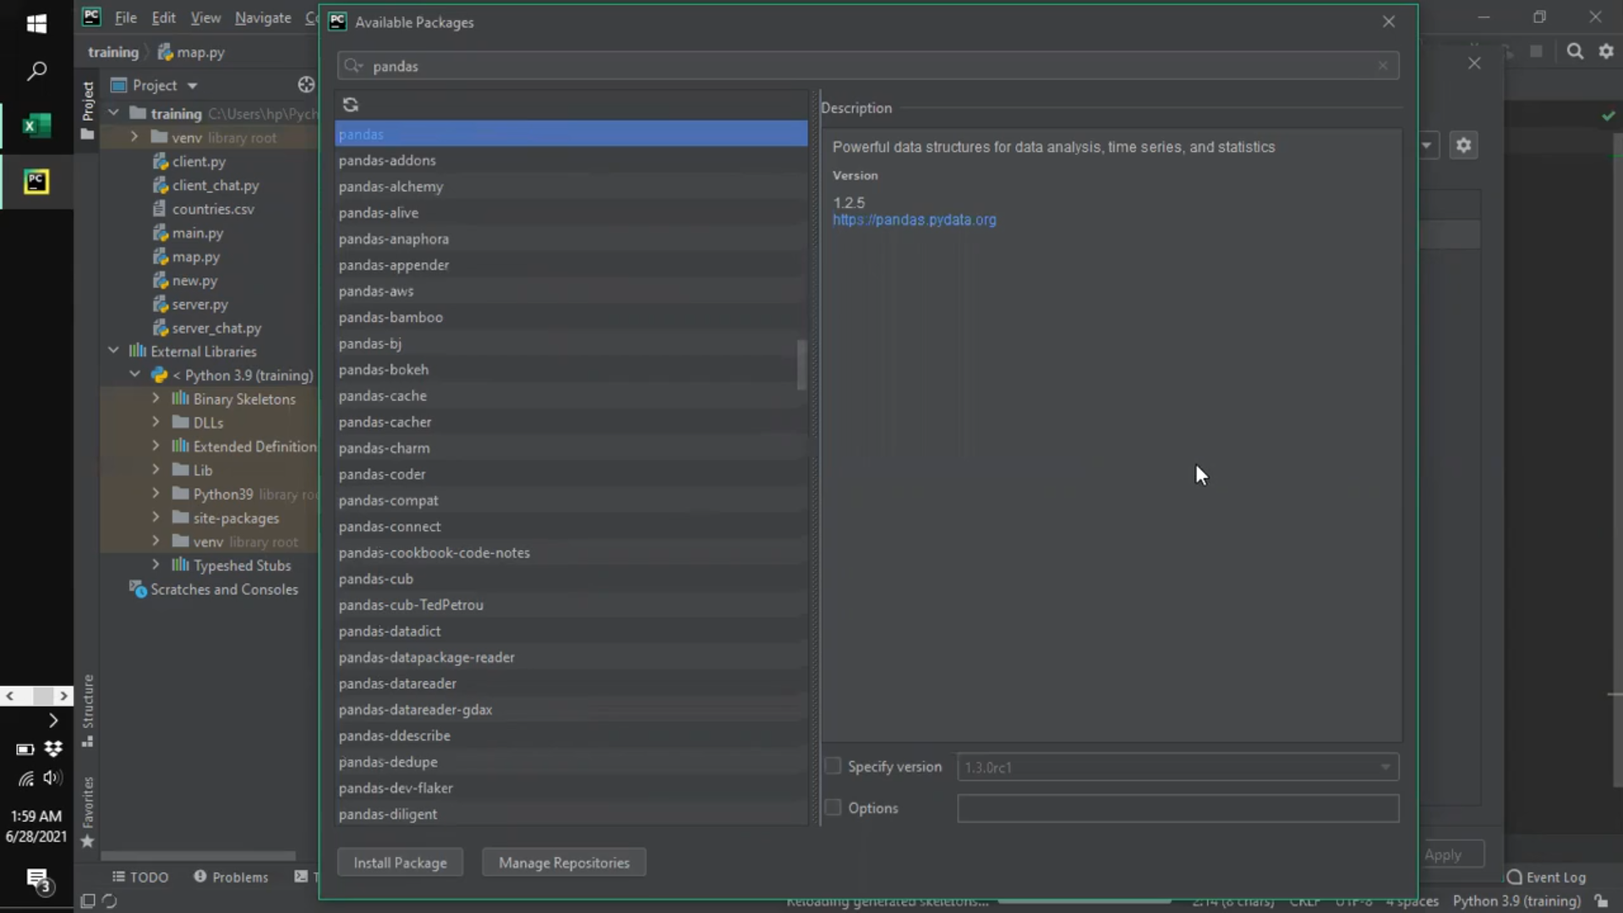

Similarly for influxDB.

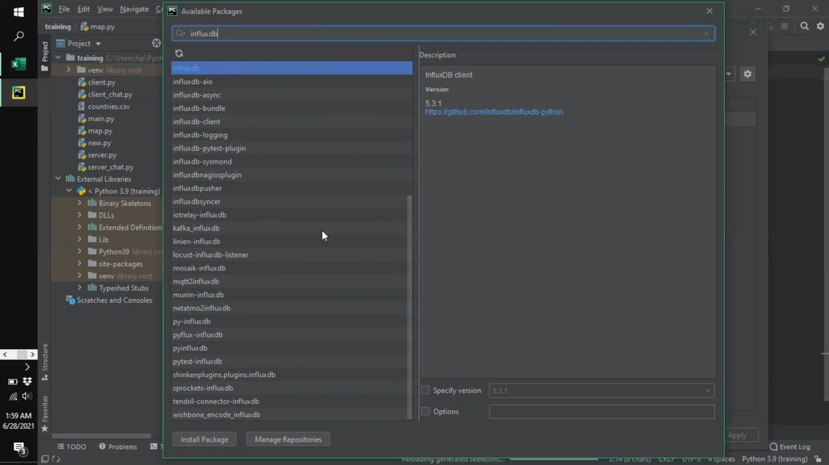Now copy the csv file of the live covid active covid cases and paste it to PyCharm.

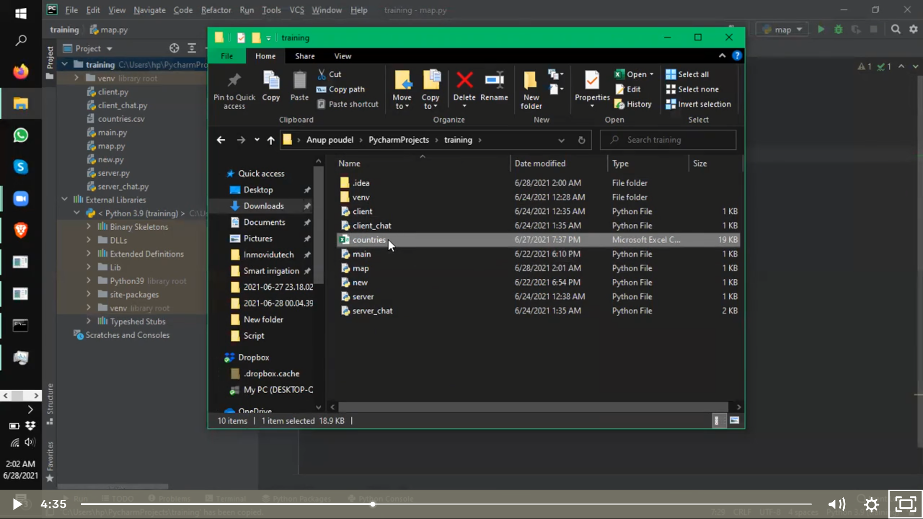

Once the installation is done as we can see and then just simply right click it and run the program.

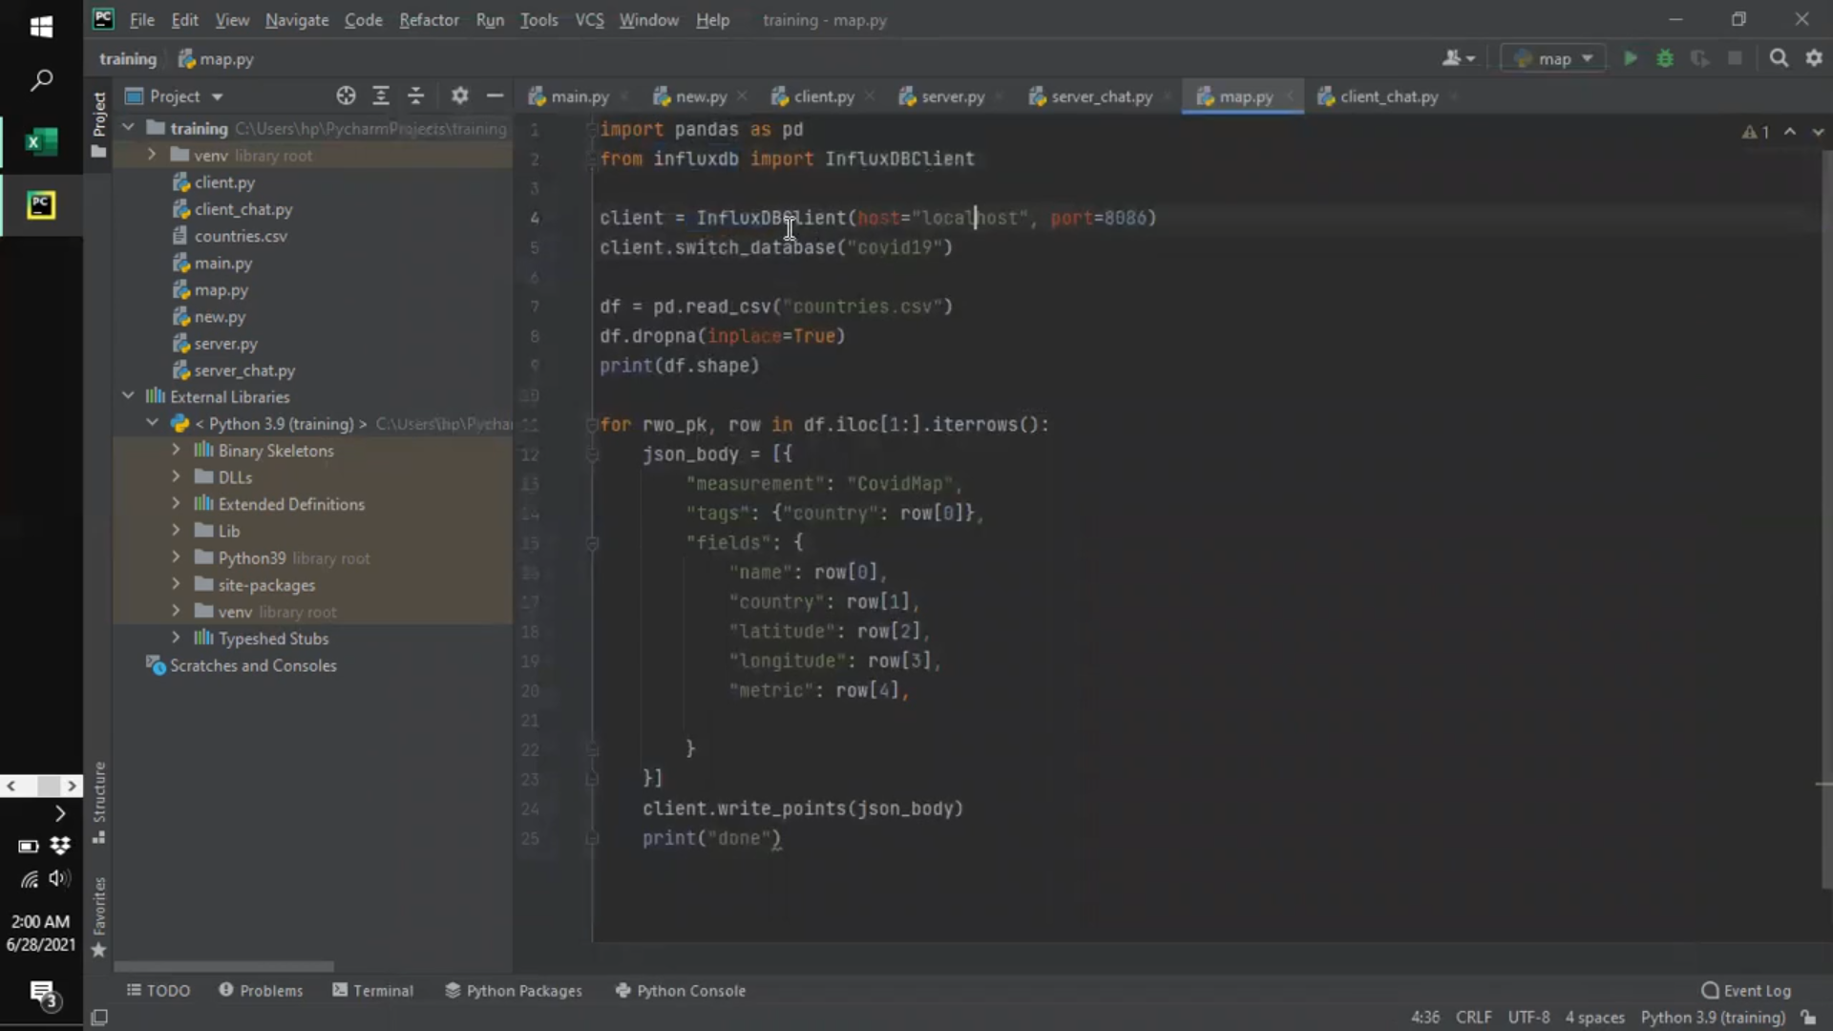

10-So finally we are almost ready getting the output, all we have to do a bit of changes in the dashboard/edit panel to interface it with the database smoothly and in a correct way.

Chose Influx DB as the data source and chose the origin location “FROM”

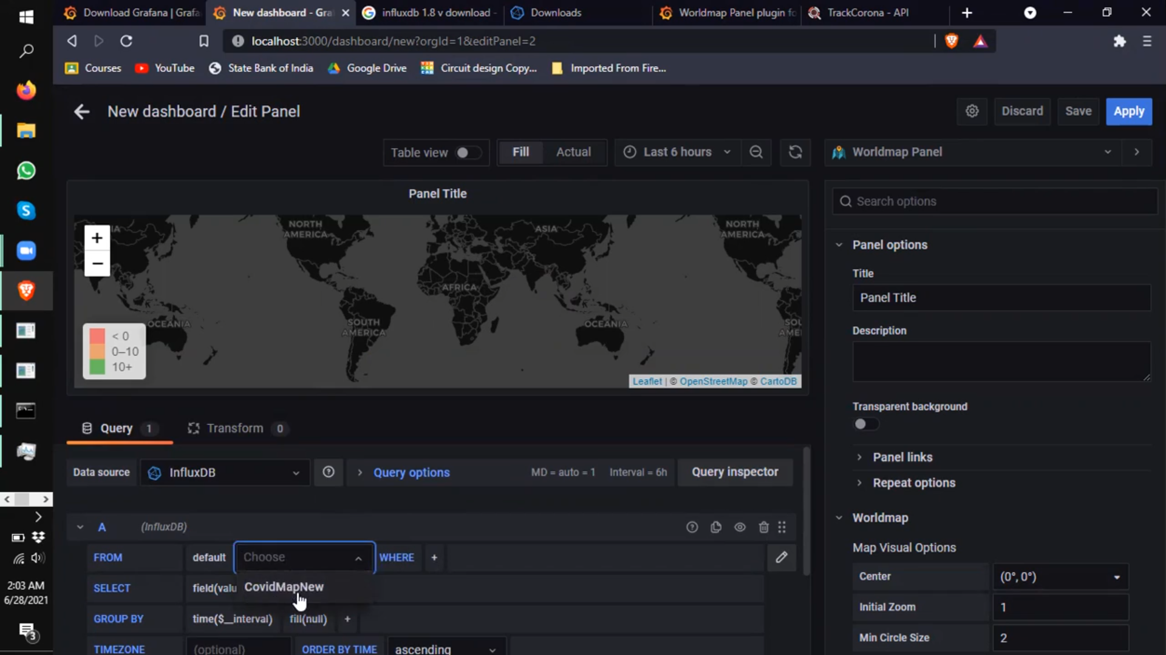

Create 5 fields along with the country to be shown, remember that the country is not like a particular one it is as a whole every country and, and field it is the type of data we have to fill in with as country, latitude. Longitude and metric.

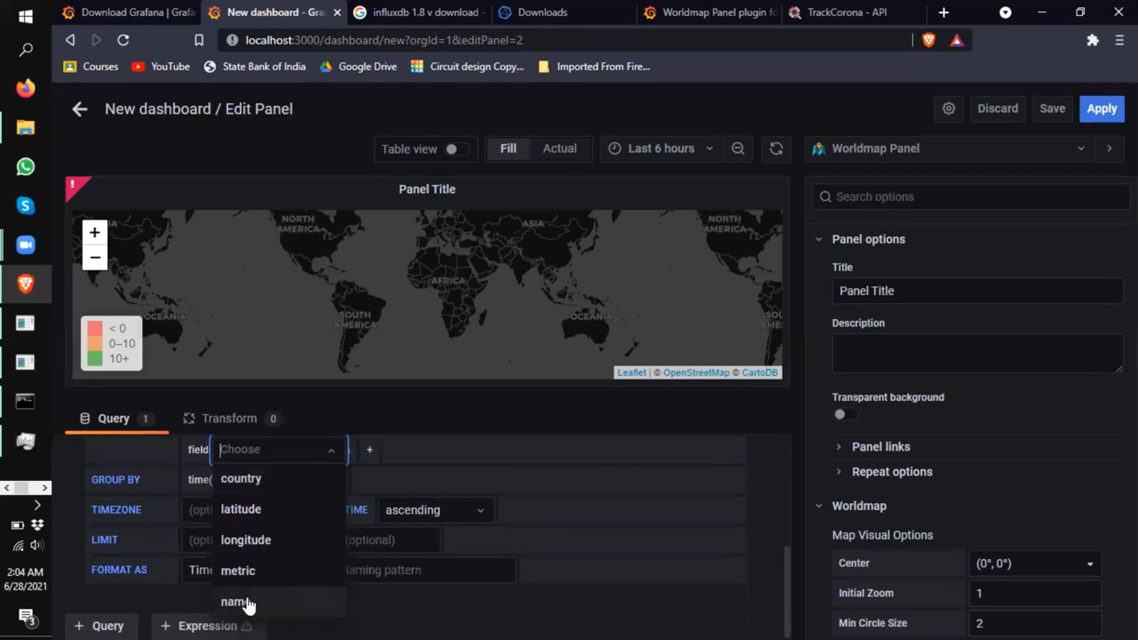Remove the grouping as time interval, as we are not using time series plotting over here.

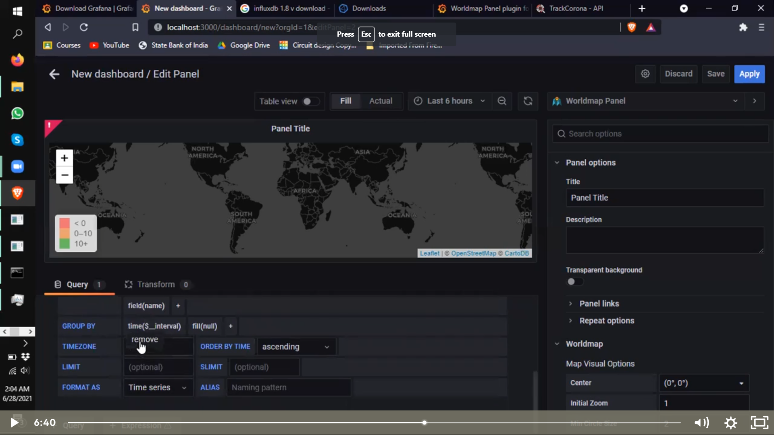And arrange the FORMAT AS Table.

Now under Map Data Options, Chose the location data as table format.

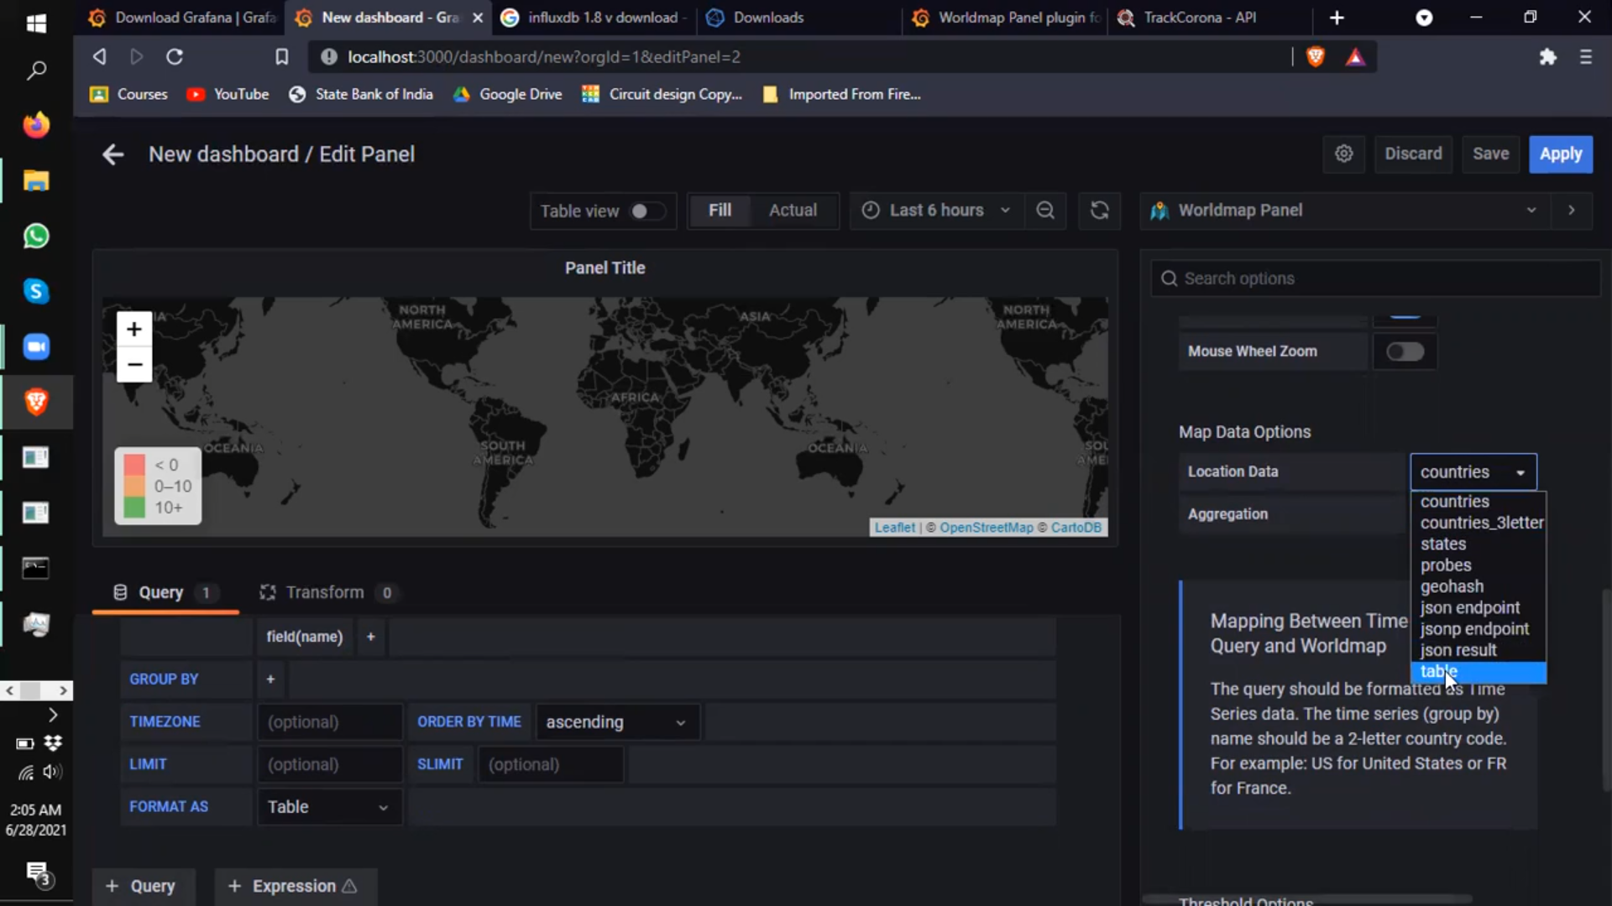Now under Field Mapping chose the Table Query Format as coordinated, instead of geohash.

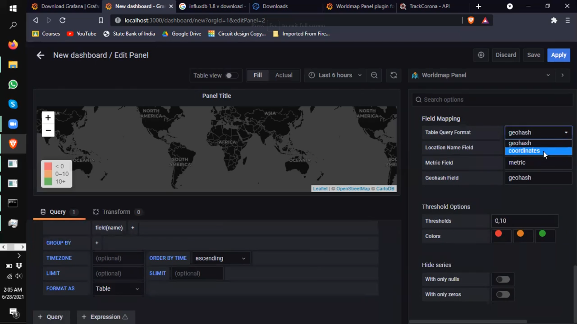

This is how it works we can even customize with respect to colour, threshold and so on. 